**REAL TIME EXPRESSION DETECTION OF MULTIPLE FACES USING DEEP LEARNING**

Shreya Mishra   
Department of Electronics and Communication  
Galgotia College of Engineering and TechnologyGr. Noida, India  
shreyamishra.avi@gmail.com

Shubham Kumar  
Department of Electronics and Communication  
Galgotia College of Engineering and TechnologyGr. Noida, India  
shubhamjha12113@gmail.com

Dr. Jaspreet Kour  
Department of Electronics and Communication  
Galgotia College of Engineering and TechnologyGr. Noida, India  
jas.kaur@galgotiacollege.eduShubham Gautam  
Department of Electronics and Communication  
Galgotia College of Engineering and TechnologyGr. Noida, India  
shubgautam21@gmail.com

*Abstract*— A facial expression is like a gesture which is executed with the facial muscles, and it conveys the emotional state of the subject to the observer. As technology is progressing it is important for the robots to understand human emotions for better communication. We investigate the field of facial expression recognition with deep learning by using Convolutional Neural Network (CNN) algorithm. The proposed framework is trained with FER2013 dataset and tested in real time. Several pooling layers are used in the training part for extracting the features out of the images and haarcascade classifier is used to identify the presence of face in the frame. Our system can recognize five universal emotions of the Facial Action Coding System (FACS) i.e., happy, sad, neutral, surprise and angry which can be identified by the face of a person. It can detect the expressions of multiple faces at the same time. The training accuracy obtained by the system is 73.12%. The real time experiment showed an excellent result.

Keywords— Facial Action Coding System, Convolutional Neural Network, Classifier, Feature Extraction, Face Detection, Human emotion.

# Introduction

Facial Expression is something that conveys our thoughts, ideas and emotions without communicating to others. Facial Expression is a form of non-verbal communication. When we travel around the world and found that different people with different native languages, our expressions and gestures play a major role in connecting us. Creating an automatic Facial Expression Recognition System (FERS) for facial action analysis is constant motivation for exploring the field of image processing. Nowadays, Machine Learning becomes a core of Artificial Intelligence and the current leading application of AI is Emotion Recognition in photos and videos. As Technology is progressing the robots need to understand human emotions for better communication. Since, applications of emotion recognition are increasing from the past decade it has invited a lot of research in the region of image processing.

This research paper mainly focuses on the deep learning concept to recognize the emotions of a person in real time by using Keras. There are three key steps that constitute the traditional Facial Expression Recognition (FER) and they are preprocessing of image, feature extraction out of the image and the expression characterization. In face detection we consider the location of the face regions. The number of resources in the feature extraction needed for the processing gets reduced and output must be important and relevant information for the further analysis which increases the accuracy of the learned model. There are some key facial elements which constantly changes when observer express his\her emotions. Subsequently, similar features in various pictures of emotions have various positions which helps in classifying the emotions accurately.

# Literature Review

Facial Expression Recognition using face-regions [1] In this paper they have used an Interface algorithm for detecting the facial landmarks of the face based on the basic states of emotion recognition. Then, in the preprocessing stage before performing the feature extraction the ROI’s are resized and partitioned into the blocks, to build a face feature as multiclass Support Vector Machine which is used for emotion detection. Here, database used is CK and the accuracy obtained is 89.85%.

A New Approach for Automatic Face Expression Recognition and Classification based on Deep Networks [2]. In this they have used a CNN network of three layers for recognition of emotions followed by max pooling and ReLU. They have trained their network on FER2013 dataset and testing is performed on the RaFD dataset. The accuracy obtained by the model is 68%. Online Facial Expression Recognition based on Personalized Galleries [3]. In this paper they have utilized an online facial expression acknowledgment framework which depends on the customized display. Personalized Gallery of 9 persons has been used to train the network and the accuracy obtained for familiar persons is 85% and that of unfamiliar persons is 65%. An Approach to Face Detection and Recognition [4]. In this paper they show that by joining the two algorithms i.e., viola Jones algorithm and principle component analysis quick detection and high accuracy can be obtained. They tested their algorithm on a dataset containing more than 1000 images and the accuracy obtained is 90%.

Face Detection and Facial Expression Recognition System [5]. In this they identify face appearance utilizing facial expression recognition framework with a brief clarification of three phases of facial identification. They have utilized their own dataset and it gives a recognition rate of 90 - 95 %.Artificial Neuro-Fuzzy Inference System has been utilized as a further improvement because of its vagueness for real time or robust images. Automatic facial expression recognition based on deep convolutional neural network structure [6]. In this paper they have used Convolutional Neural Network algorithm containing two convolutional layer and two subsampling layers to achieve the facial expression detection system. Firstly, Haar-like feature and histogram equalization are used by them to implement a face detection. Then a 4-layer CNN architecture which includes two convolutional layer and two subsampling layers has been constructed. The database used is JAFFE and CK+ and accuracy obtained is 76.7442% and 80.303%.

Facial Expression Classification System based on Active Shape Model and Support Vector Machine [7] This paper used facial segments to find dynamic facial texture, for example, grimace lines, nose wrinkles, and nasolabial folds to distinguish changes in expression. They have utilized AdaBoost utilizing haar-like elements and furthermore Active Shape Model to precisely identify the facial expressions. The Database used is Cohn-Kanade and the accuracy is 91.7%. Facial expression detection using Six Facial Expressions Hexagon (SFEH) Model [8]. In this they proposed a model which gives an overall portrayal of six facial expressions on six edges of surface hexagon which is at the external boundary of face in this analysis all about 900 points are utilized for the entire face and coordinating is finished by taking the contrast between the relating pixels. The database used is AR and grammatical facial expression and accuracy is 81% with AR and 95% with grammatical facial expression dataset.

An efficient approach for recognizing and tracking spontaneous Facial Expressions [9]. The fundamental target of this research is to track and detect the facial expression for a given video, which later can be utilized to foresee a human conduct. The database used is Cohn-kanade and accuracy is 89%. Facial Expression Detection using Facial Expression Model [10]. In this paper they discuss about different types technique of facial expression recognition. FACS system is used for all different technique. (1) 1-D Techniques: Independent Component Analysis, Linear Discriminant Analysis, Principal Component Analysis. (2) 2-D Technique: 2dimensional Principal Component Analysis, Sub pattern extended 2-dimensional PCA, Global Eigen Method (3) Multi-linear Image Examination and Color Subspace Linear Discriminant analysis. Recognizing emotions from an ensemble of features [11]. In this paper they initially perform preprocessing, then extracted the features that incorporate SIFT, HG and MFs. The database used is GEMEP-FERA and overall accuracy obtained is 80%Fully automatic recognition of the temporal phases of facial actions [12]. In this research paper they have proposed that both AU activation detection based on geometric features as well as detection of four temporary phases is possible with high precision. The database used is CK and MMI and the accuracy obtained is 95.3%

Automatic facial expression recognition using features of salient facial patches [13]. They proposed a framework in which they have selected facial patches with the help of appearance feature for the facial expression detection. A programmed learning facial landmark detection strategy has been used by them that performs well in dissimilar resolutions and it provides a solution for the recognition of expressions in less resolution images. The database used is CK+ and JAFFE and significant accuracy obtained is 89.64% and 85.06%. Facial Expression Recognition Using Facial Movement Features [14]. This paper investigates the issue of recognition of face expressions utilizing facial movement feature (Gabor). The point of the paper is to check the working of FER via automatically catching facial development features in static pictures. By JAFFE the proposed method gives the best result with an accuracy of 92.93% utilizing DL2 and direct SVM. By using CK dataset the proposed approach gets the most elevated accuracy of 94.48% utilizing DL2 and RBF SVM.

Image Ratio Features for Facial Expression Recognition Application [15]. In this journal the main concern was to improve texture feature. In the system the Cohn–Kanade, JAFFE and Custom database used and SVM is used for classification of expressions. The average accuracy of image ratio feature is 89.7%,90.8% and 91.2% where as old texture feature high gradient component features 83.3%, 88.3% and 90.4% respectively to databases. Identifying Human Emotions from Facial Expressions with Deep Learning [16]. Dataset containing mixed set of facial expressions has been used by them for training the model. Three layered CNN is used as a classifier, as CNN neural networks give highest accuracy rate when compare to another neural network-based classifier. The database used is FER2013 and the accuracy obtained is 79.8%.

# Methodology

Figure (1) explains the proposed method. Firstly, the system is trained with the FER2013 dataset which contains 5 categories of emotions (Happy, Sad, Anger, Neutral and Surprise) and around 27,182 images. While training in the pre-processing stage, several pooling layers along with the Elu and Softmax activation functions are used for the feature extraction. After training the model it is used for predicting the emotions in real time by using the webcam.

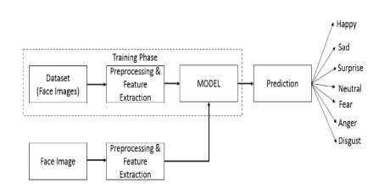

*Fig. (1) Architecture of the model [16]*

## Dataset

Facial Expression recognition (FER2013) dataset is used to train the model. It is an open-source dataset containing 35,687 gray scaled images of 48*48 pixels of seven different categories. We used 27,182 images i.e., five emotions to train our model. Our model can recognize five emotions and they are Happy, Sad, Angry, Surprise and Neutral. Out of the 27,182 images 24,176 images are utilized as training data and 3006 images are utilized as validation data. fig. (2) shows some example images of FER2013 dataset.

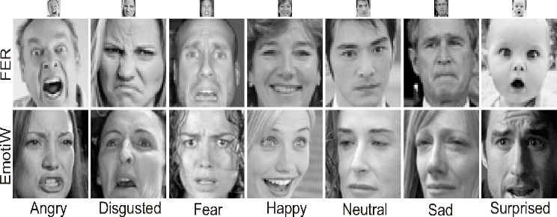

*Fig.(2) FER2013 Dataset [17]*

## Convolutional Neural Network

Convolutional Neural Network (CNN) algorithm is used in the model as CNN yields maximum accuracy as compared to other neural networks. CNNs are widely utilize in the field of image detection, object detection, images recognition, face recognition etc. Computer sees Input image as an array of pixels. CNN takes the input image it will do the resolution and preprocess the image and classify it on the basis of the data used during the training of the model. fig. (3) clarifies the architecture of CNN neural network.

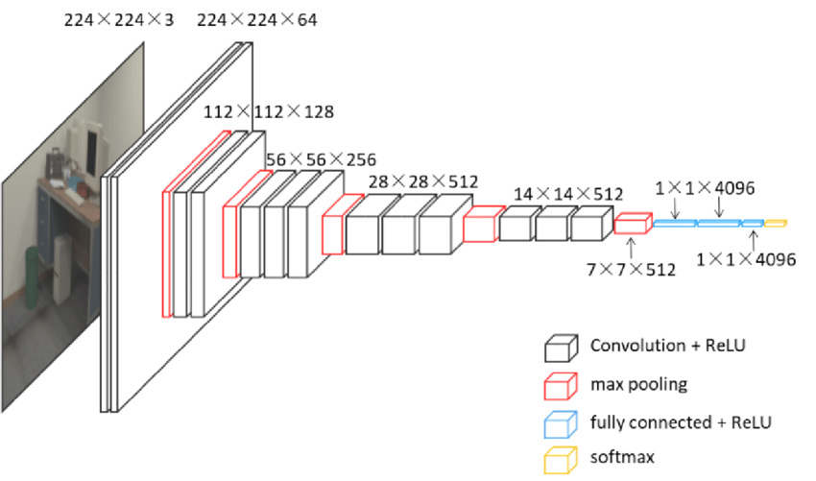

*Fig. (3) Architecture of CNN [18]*

## Maxpooling

Pooling layer is a building structure of convolutional neural network and the most well-known methodology of pooling is max pooling. It chooses the maximum features from the feature map. Thus, the output obtained after the max pooling layer is the feature map containing the most important features of the previous features map. Maxpooling layer is explained in fig. (4).

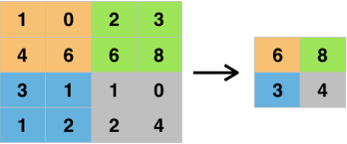

*Fig. (4) Maxpooling layer [19]*

## Elu

Elu is known as Exponential Linear Unit. In our proposed model we used Elu to set the threshold value. It is an activation function that tends to converge the cost to 0 faster and it produces accurate results. As compare to other activation functions, ELU has one extra constant alpha which should be a positive number. It is similar to RELU except the negative inputs. When the output of ELU is equals to -alpha it starts smooth slowly whereas RELU smoothes sharply.

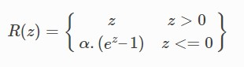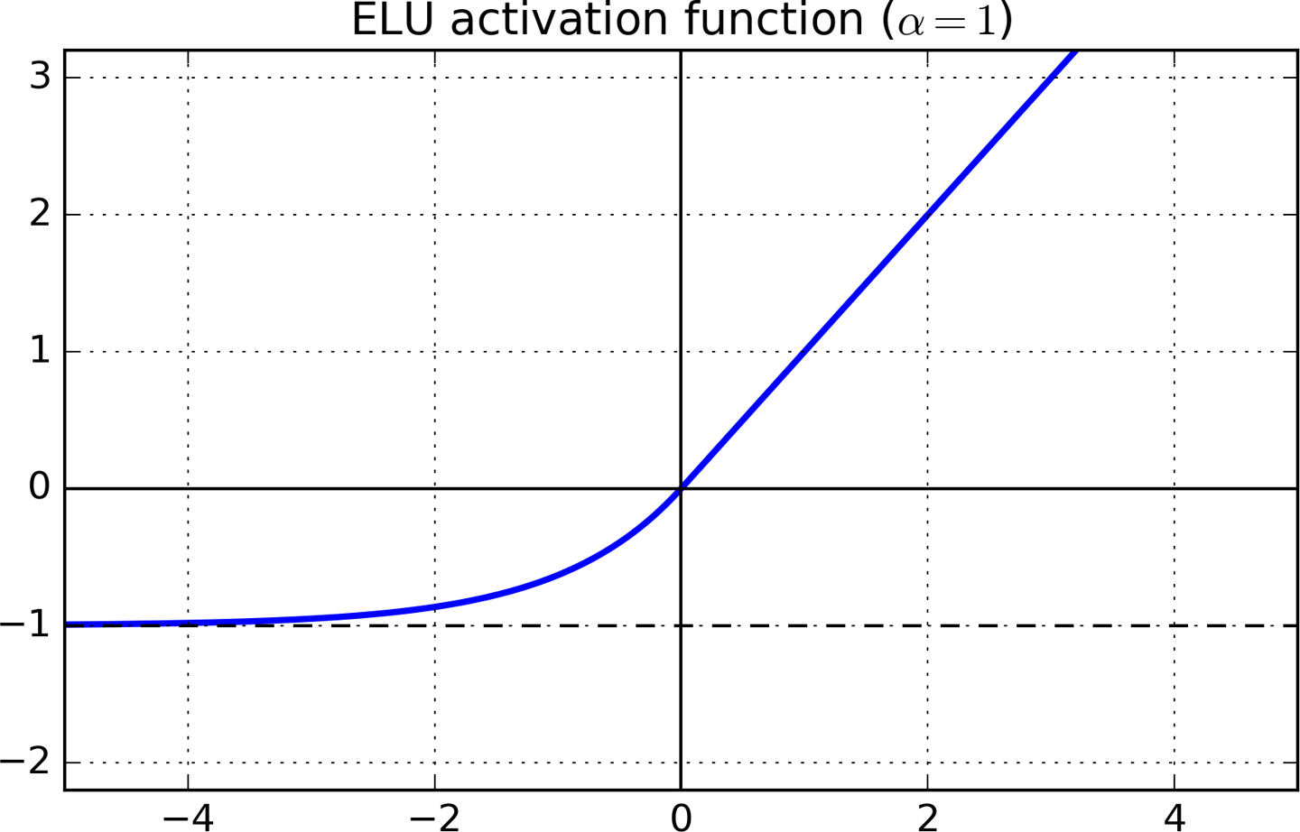

*Fig. (5) ELU activation function [20]*

## Softmax

In Deep Learning particularly in Convolutional Neural Networks the SoftMax layer is used as the last layer at the end of the network that yields your actual probability scores for each section or class labels. It is very useful as it converts to normalized frequency distribution which can be used by the other systems as their input. It is implemented just before the output layer. The formula for calculating the softmax is given below.

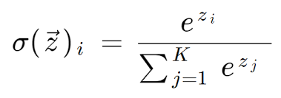

# Experimental Result

The proposed model is trained with a learning pace of 0.001 for 450 epochs in the last run of the model. Our model has been trained with 27,182 images out of which 24,176 images were used for training the model and 3006 were used for the validation. Live emotion recognition from the webcam was performed by the model with the help of OpenCV and Haar-cascade classifier at the testing stage to classify the emotions. Our model can recognize five emotions i.e. Happy, Sad, Angry, Surprise and Neutral. The accuracy obtained while training the model is 73.12%. We have run the Convolutional Neural Network for several times to determine the exactness of the model and performed our final run on a device powered by Nvidia GeForce GTX MX130 GPU of 2GB with 8GB of RAM.

|  |  |  |
| --- | --- | --- |
| No. of Epochs | Time Taken | Accuracy (%) |
| 25 | 5hr. | 55.14% |
| 100 | 16hr. | 65.25% |
| 250 | 54hr. | 68.80% |
| 450 | 102hr. | 73.12% |

*Table1: Accuracy of training result*

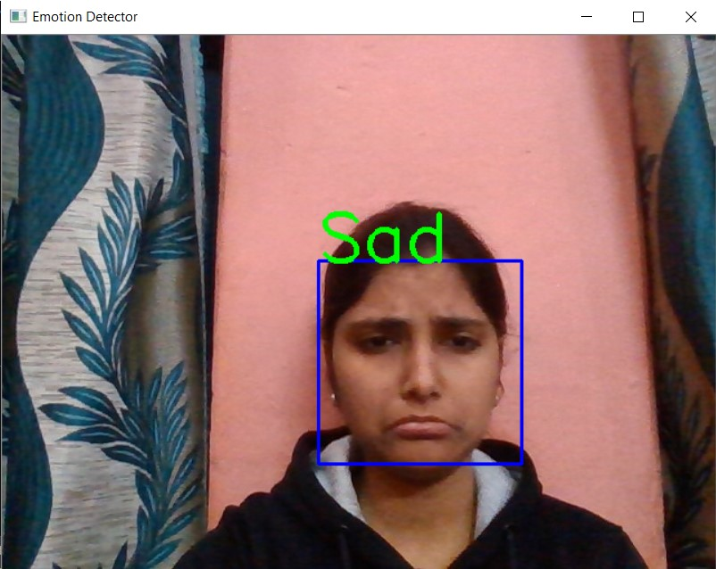

*Fig.6(a) One face is detected in the frame showing Sad emotion.*

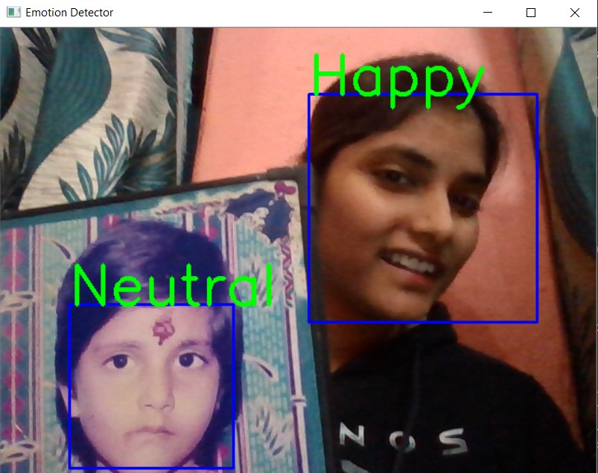

*Fig.6(b) Two faces are detected in the frame showing happy and neutral emotions.*

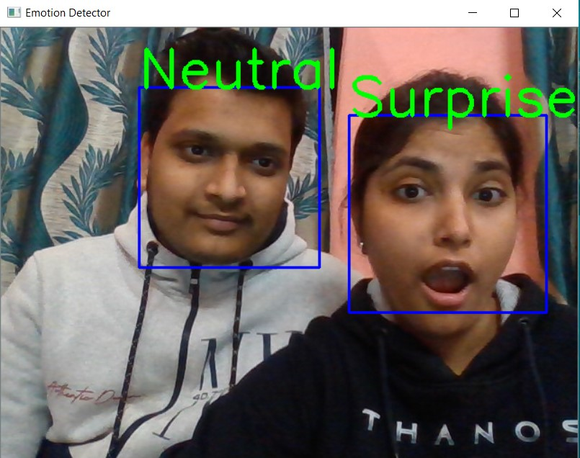

*Fig.6(c) Two faces are detected in the frame showing neutral and surprise emotions*.

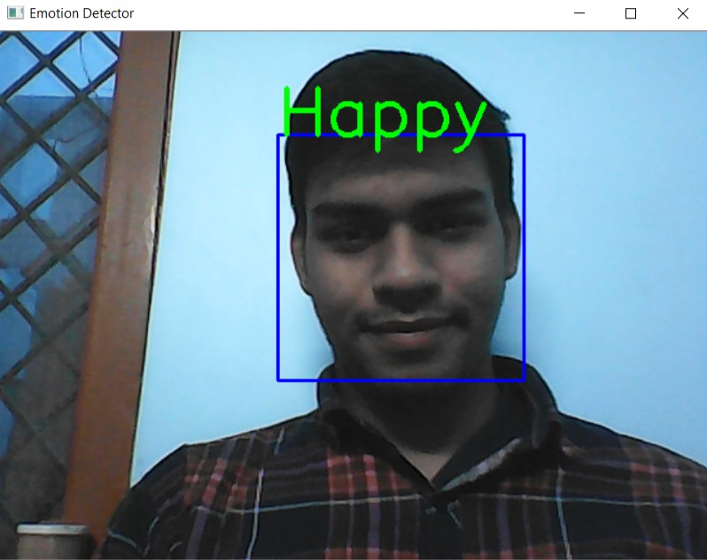

*Fig.6(d) One face is detected in the frame showing happy emotion*.

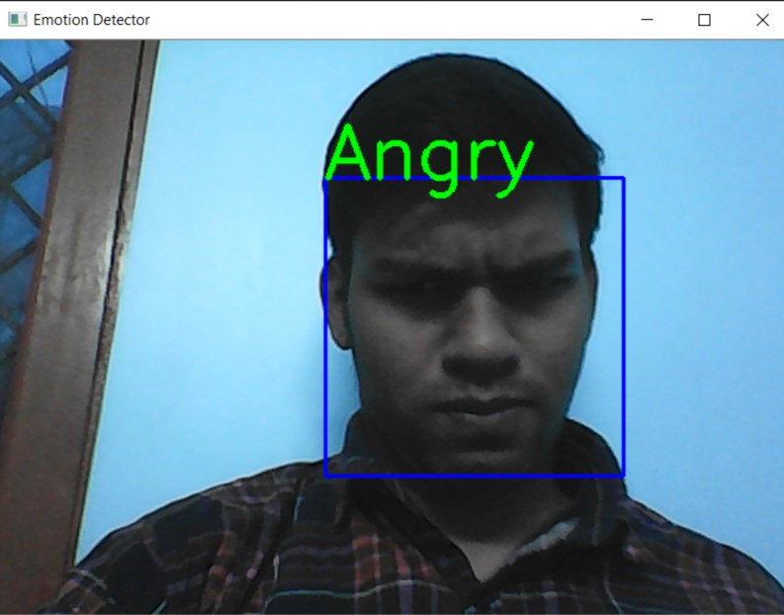

*Fig.6(e) One face is detected in the frame showing angry emotion.*

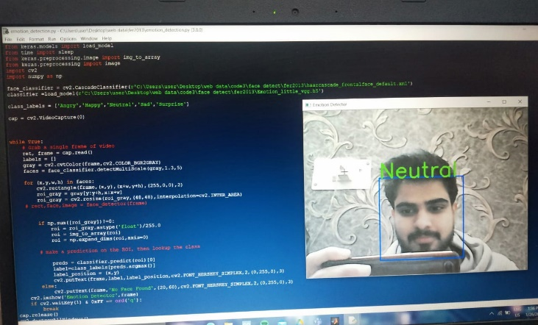

*Fig.6(f) one face detected in the* *execution window of our model with neutral emotion*

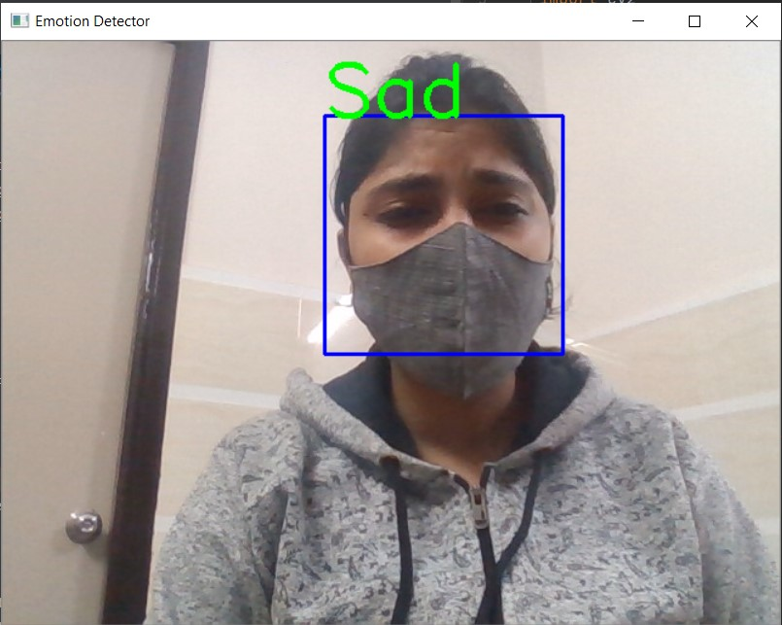

*Fig.6(g) An occluded face, detecting sad emotion*

# Conclusion and Future Work

Automatic Facial Expression Recognition System (FERS) has enormous amount of uses from security purpose to connecting with different people with different languages. The proposed model can detect multiple faces in webcam it is not limited to a single face detection. Due to the unbalanced dataset the accuracy obtained by training the model is less but the proposed system showed excellent result while testing. In future, we will apply this algorithm on larger datasets and will also use different neural networks to obtain the high accuracy.

##### References

1. Khadija Lekdioui, Rochdi Messoussi, Youness Chaabi, Raja Touahni “Facial Expression recognition using face-regions.” 3 RD International conference on advanced technologies for signal and image processing –Atsip’2017, May 22-24,2017, Fez Morocco, pp.1-6.
2. Vibha. V. Salunke, Dr. C.G. Patil “A new approach for Automatic Face Emotion Recognition and Classification based on deep networks.” 2017 International Conference on Computing, Communication, Control and Automation (ICCUBEA), Pune, 2017, pp.1-5.
3. Hai Hong and C. Von Der Malsburg “Online Facial Expression Recognition using Personalized Gallery.” 3 rd IEEE International Conference on Automatic Face and Gesture Recognition, Nara,1998, pp.354-359.
4. Divya Meena Ravi Sharan “An Approach to Face Detection and Recognition,” IEEE International Conference on Recent Advances and Innovations in Engineering (ICRAIE-2016), December 23-25, 2016, Jaipur, India, pp.1-6.
5. Anagha S. Dhavalikar and Dr. R. K. Kulkarni “Face Detection and Facial Expression Recognition System.” International Conference on Electronics and Communication systems (ICECS), Coimbatore Year: 2014, pp.1-7.
6. Ke Shan, Junqi Guo, Wenwan You, Di Lu, Rongfang Bie “Automatic facial expression recognition based on deep convolutional neural network structure.” IEEE 15th International Conference on Software Engineering Research, Management and Applications(sera), London, 2017, pp.123-128.
7. Chen- Chiung Hsieh and Meng-Kai Jiang “Facial Expression Classification System based on Active Shape Model and Support Vector Machine.” International symposium on computer science and society, Kota Kinabalu, Year- 2011, pp.311-314.
8. Marryam Murtaza, Muhammad Sharif, Musarrat Abdullah Yasmin, Tanveer Ahmed “Facial expression detection using Six Facial Expressions Hexagon (SFEH) model.” 9 th Annual Computing and Communication Workshop and Conference (CCWC), Las Vegas, NV, USA, Year2019, pp.0190-0195.
9. J. Zraqou, W. Alkhadour, A. Al-NU’AIMI “An efficient approach for recognizing and tracking spontaneous facial expressions.” Second International Conference on E-learning and etechnologies in education (ICEEE), Lodz, Poland Year:2013, pp.304-307.
10. Hari Prasad Mal and Dr. Swarnalatha P “Facial Expression Detection using Facial Expression Model.” International Conference on Energy, Communication, Data Analytics and Soft Computing (ICECDS), Chennai, Year: 2017, pp.1259-1262.
11. Usman Tariq, Kai-Hsiang Lin, Zhen Li, Xi Zhou, Zhaowen wang, Vuong le, Thomas s. Huang “Recognizing emotions from an ensemble of features” IEEE Transactions on Systems, Man and Cybernetics- Part B: Cybernetics, Vol. 42, No. 4, pp.1017-1026, August 2012.
12. Michel F. Valstar and Maja Pantic “Fully automatic recognition of the temporal phases of facial actions.” IEEE Transactions on Systems, Man and Cybernetics- Part B: Cybernetics, Vol. 42, No.1, pp.28-43, February 2012.
13. S L Happy, Aurobinda Routray “Automatic Facial Expression Recognition using Features of Salient Facial Patches.” IEEE Transactions on Affective Computing, vol. 6, no. 1, pp.1-12, Year: January- march 2015.
14. Ligang Zhang and Dian Tjondronegoro “Facial Expression Recognition Using Facial Movement Features.” IEEE Transactions on Affective Computing, vol. 2, no. 4, pp. 219-229, October-December 2011.
15. Mingli Song, Dacheng Tao, Zicheng Liu, Senior, Xuelong Li and Mengchu Zhou “Image Ratio Features for Facial Expression Recognition Application.” IEEE Transactions on Systems, Man, And Cybernetics-Part B: Cybernetics, vol. 40, no. 3, pp.779-788, June 2010.
16. P. Babajee, G. Suddul, S. Armoogam and R. Foogoa “Identifying Human Emotions from Facial Expressions with Deep Learning.” Zooming Innovation in Consumer Technologies Conference (ZINC), Novi Sad, Serbia, Year: 2020, pp.36-39.
17. Anmol Uppal, Shweta Tyagi, Rishi Kumar, Seema Sharma “Emotion recognition and drowsiness detection using python.” 2019 9th International Conference on Cloud Computing, data Science and Engineering (Confluence), Noida, India, 2019, pp. 464-469
18. Chen, Yujin, Chen, Ruizhi, Liu, Mengyun, Xiao, Aoran , Wu, Dewen, Zhao, Shuheng. (2018). Indoor Visual Positioning Aided by CNN-Based Image Retrieval: Training-Free, 3D Modeling-Free. Sensors. 18. 2692. 10.3390/s18082692.
19. <https://www.google.com/imgres?imgurl=https%3A%2F%2Fimages.deepai.org%2Fglossary-terms%2Fmax-pooling-4803093.jpg&imgrefurl=https%3A%2F%2Fdeepai.org%2Fmachine-learning-glossary-and-terms%2Fmax-pooling&tbnid=_jwdbJXARmkx-M&vet=1&docid=YWHa5YfZt-6KsM&w=860&h=358&hl=en-IN&source=sh%2Fx%2Fim>
20. <https://datascience.stackexchange.com/questions/22037/why-does-it-speed-up-gradient-descent-if-the-function-is-smooth?hcb=1>